Name: ____________________________ Math 153 Test #3

1. Read the sentences below and then identify each **underlined (bold)** number by labeling it with the proper statistical symbol. (6 pts)

Jordan wanted to figure out the average number of people living in each house in Maryland. He randomly selected **100** houses from the phone book and called each one to ask how many people live in the house. The average number he calculated for the people that answered the phone was **4.8.** He knows based off of a previous study the standard deviation for the number of people per household in Maryland is **1.7**. In another study he asked those same 100 people if they enjoyed living in their neighborhood and **73%** said that they did.

1. Describe the difference between a parameter and a statistics, then draw the symbol that shows a proportion as a parameter and a statistic. (4 pts)

______________________________________________________________

______________________________________________________________

______________________________________________________________

______________________________________________________________

Statistic proportion: ____________ Parameter Proportion: _______________

1. Out of a random sample of 50 students surveyed at a very large school 34 of them said they like to go to the movies. Assuming conditions are met and using the information above, what would be the approximate value of the standard error of our sampling distribution of sample proportions? (3 pts)
2. What is the difference between a One-Sample T-Interval and a One-Sample Z-Interval? (3 pts)
3. An SRS of 240 first-year college students were asked whether they applied for admission to any other college. In fact, it is known that 76% of all first-year students applied to colleges besides the one they are attending. What is the probability that the poll will give a sample proportion between 73% and 77%? (8pts)
4. If mean of a population that is normally distributed is 20 and the standard deviation of the population is 4. Sketch the sampling distribution of sample means for a sample size of 25. (4 pts)

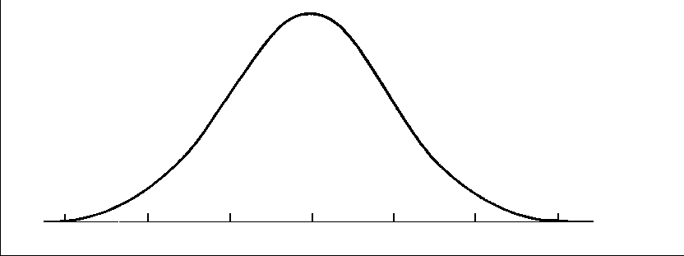

1. A population of manufactured products where the random variable X is the weight of the item. Prior experience has shown that the weight has a normal distribution with mean 6.0 ounces and standard deviation of 1.2 ounces.
   1. What is the probability that the weight of “one” item randomly selected will weigh more than 7.6 ounces? (4 pts)
   2. What is the probability that if the manufacturer takes a random sample of 100 items, that it has a mean weight of more than 6.2 ounces? (6 pts)
2. Lie detectors are based on measuring changes in the nervous system. The assumption is that lying will be reflected in physiological changes that are not under the voluntary control of the individual. When a person is telling the truth, the galvanic skin response scores have a distribution that is normal with a mean of 51.6 and a standard deviation of 9. (Assume ALL Conditions are met)

What is the probability that a sample of 10 people will have an average score less than 49.5? (6 pts)

For Questions #9-10 make sure to show **all** aspects of a confidence interval (15 pts each)

1. A company that produces batteries is concerned about the distribution of the life expectancy of their batteries. The company takes a simple random sample of 50 batteries and computes the sample mean to be 800 hours per battery and a standard deviation of 25 hours. Construct and interpret a 90% confidence interval for the unknown mean life expectancy.
2. In a simple random sample of 200 students taken at a very large university, 64 stated that they enjoy strawberry ice cream. Construct and interpret a 99% confidence interval for the percent of students at the university who enjoy strawberry ice cream.
3. The **actual** time it takes to cook a 28-pound turkey is a **normally distributed** random variable with a **mean of 5.3** hours and a **standard deviation of 0.8 hours**.
4. What is the probability that the average cooking time of a single 28–pound turkey will take less than 4.4 hours to cook? (4 pts)
5. Assuming all conditions are met, what is the probability that the mean cooking time for a random sample of 36 of these 28-pound turkeys would be greater than 5.4 hours? (6 pts)
6. Given that an average of 5.15 hours was found for the sample of 36 turkeys, calculate and interpret a 90% confidence interval for the average cooking time of a 30–pound turkey. (**ONLY** calculate and interpret the interval) (6 pts)
7. Is the parameter that you are trying to estimate in (c) actually in the interval? What is the parameter? (3 pts)
8. It is generally believed that nearsightedness affects about 14% of children. A large school district gives vision tests to 144 randomly selected incoming kindergarten children.
9. Can we calculate the mean and standard deviation of the sampling distribution? If so, calculate each one (Show Conditions). (5 pts)
10. If we created a confidence interval and wanted to become more confident in our response without changing the width of your interval what would have to change? (Explain in basic terms) (2 pts)

**FORMULAS**

MEANS OF SAMPLING DISTRIBUTIONS





