





















A deck of cards has 3 blue, 4 black, and 6 purple cards. You pick 2 cards from the deck. Cards are not returned to the deck after they are picked.  
P(two blue cards in a row)

What is the probability of scoring a total of 18 when three fair dice are rolled? (Hint: the only way of getting a score of 18 is if the three dice shows a 6 each.

Two fair dice, one coloured white and one coloured red, are thrown. Find the probability that:

1. the score on the white die is 1 and red die is even.
2. the score on the white die is either 3 or 5 and the red die is odd.

Two sets of cards with a letter on each card as follows are placed into separate bags.   
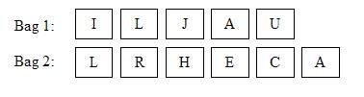  
Sara randomly picked one card from each bag.   
Find the probability that:

1. She picked the letters ‘J’ and ‘R’.
2. Both letters are vowels.