Practice Test #1 Statistics Name:

Part 1: Multiple Choice. Circle the letter corresponding to the best answer.

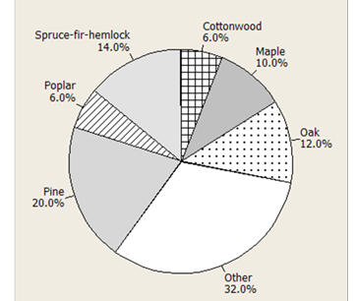
1. The pie chart at right describes the distribution of state tree types for the 50 states in the United States. The category “Other” include all trees that are the state tree for two or fewer states. Which of the following conclusions can we draw from this chart?
(a) Some states have not designated a “state tree.” (b) The cottonwood is the state tree for 12 states.
(c) Taken together, oak, pine, and maple are the state trees for more than half the states.
(d) There are 10 states that have designated a pine as their state tree.
(e) There is no state that has designated the Eastern Red
Cedar as its state tree.

2 The following bar graph gives the percent of owners of three brands of trucks who are satisfied with their truck. From this graph, we may conclude that
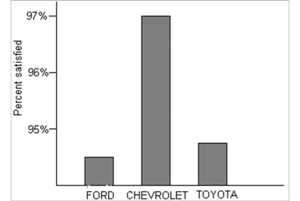
(a) owners of other brands of trucks are less satisfied than the owners of these three brands.
(b) Chevrolet owners are much more satisfied than Ford or
Toyota owners.
(c) There are only small differences in the satisfaction of owners for the three brands.
(d) Chevrolet probably sells more trucks than Ford or
Toyota.
(e) A pie chart would have been a better choice for displaying these data.

3. Here are the IQ test scores of 10 randomly chosen fifth-grade students:
145 139 126 122 125 130 96 110 118 118
To make a stemplot of these scores, you would use as stems
(a) 0 and 1.
(b) 09, 10, 11, 12, 13, and 14.
(c) 96, 110, 118, 122, 125, 126, 130, 139, and 145. (d) 0, 2, 3, 5, 6, 8, 9.
(e) None of the above is a correct answer.

4. If a distribution is skewed to the right, which of the following is true? (a) The mean must be less than the median.
(b) The mean and median must be equal.
(c) The mean must be greater than the median.
(d) The mean is either equal to or less than the median,
(e) It’s impossible to tell which of the above statements is true without seeing the data.
5. Rainwater was collected in water collectors at 30 different sites near an industrial complex and the amount of acidity (pH level) was measured. The data ranged from pH 2.6 to pH 6.3. The following stemplot of the data was constructed.
2|679
3|237789 Key: 3|7 = pH 3.7
4|1222446899
5|0556788
6|0233
Which of the following boxplots is a correct representation of the same distribution?

(a)

(b)

(c)

(d)

(e)

2.5 3.0 3.5 4.0
4.5
pH
5.0 5.5 6.0 6.5

6. A sample of 250 high school students were asked, “If you had $1000 to contribute to one kind of charitable organization, which type of organization would you choose? Below is a two-way table of responses to this question and gender.

 | Organization
Gender | Education | Environment | Health | International  Aid | Other
Female | 19 | 33 | 50 | 28 | 10
Male | 23 | 29 | 28 | 17 | 13

Which of the following conclusions seems to be supported by the data?
(a) Most of the females who chose a health organization would have chosen an environmental organization as their second choice, had they been asked.
(b) There is no association between gender and choice of organization.
(c) The proportion of males who said they would contribute to an environmental organization was higher than the proportion of females who said they would contribute such an organization.
(d) None of the students surveyed said they would contribute to religious organizations. (e) The marginal distribution of Organization is 140, 110.
7. A small company that prints custom t-shirts has 6 employees, one of whom is the owner and manager. Suppose the owner makes $120,000 per year and the other employees make between
$40,000 and $50,000 per year. One day, the owner decides to give himself a $30,000 raise. Which of the following describes how the company’s mean and median salaries would change? (a) The mean and median would both increase by $5,000.
(b) The mean would increase by $5,000 and the median would not change. (c) The mean would increase by $6,000 and the median would not change. (d) The median would increase by $6,000 and the mean would not change.
(e) The mean would increase by $6,000, but we cannot determine the change in the median without more information.

8. The mean speed of vehicles in the “cars only” lanes of the New Jersey turnpike is 68 miles per hour. The mean speed of vehicles in the “any vehicle” lanes is 64 miles per hour. What must be true about the mean speed of all vehicles on the turnpike, assuming these are the only types of lanes?
(a) It could be any number between 64 and 68 miles per hour. (b) It must be larger than the median speed.
(c) It must be larger than 66 miles per hour. (d) It must be 66 miles per hours.
(e) We don’t have enough information to draw any conclusion about the mean speed of all vehicles.

9. The mean birth weight of infants born at a certain hospital in the month of April was 128 oz. with a standard deviation of 10.2 oz. Which of the following is a correct interpretation of standard deviation?
(a) All the infants born in April weighed between 117.8 oz. and 138.2 oz.
(b) About half the infants born in April weighed between 117.8 oz. and 138.2 oz.
(c) The difference between the mean weight and the median weight of infants born in April was 10.2 oz.
(d) The distance between the weight of each infant bon in April and the mean weight was, on average, about 10.2 oz.
(e) The mean weight of infants born in subsequent months is likely to be within 10.2 oz. of the mean weight in April.

10. A medical researcher collects health data on many women in each of several countries. One of the variables measured for each woman in the study is her weight in pounds. The following list gives the five-number summary for the weights of adult women in one of the countries.

Country A: 92, 110, 120, 160, 240

About what percent of Country A women weigh between 110 and 240 pounds? (a) 50%
(b) 65% (c) 75% (d) 85% (e) 95%
Part 2: Free Response
Show all your work. Indicate clearly the methods you use, because you will be graded on the
correctness of your methods as well as on the accuracy and completeness of your results and explanations.

11. We all “know” that the body temperature of a healthy person is 98.6°F. In reality, the actual body temperature of individuals varies. Here are dotplots and summary statistics of the body temperatures for 90 healthy individuals (45 males and 45 females).

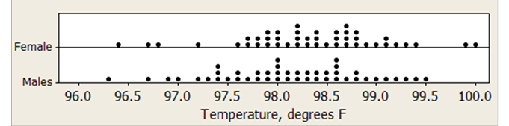

 | Total
Variable | Count | Mean | SE Mean | StDev | Minimum | Q1 | Median | Q3 | Maximum
Female | 45 | 98.344 | 0.111 | 0.745 | 96.400 | 97.900 | 98.400 | 98.800 | 100.000
Males | 45 | 98.122 | 0.110 | 0.735 | 96.300 | 97.600 | 98.100 | 98.600 | 99.500

(a) Determine if there are any outliers in each distribution. Show your work.

(b) Draw parallel boxplots of these two distributions. Be sure to label the plots and provide a scale.

(c) Write a few sentences comparing the body temperatures of healthy males and females.
12. The data below is the number of unprovoked attacks by alligators on people in Florida each year for a 33-year period.

6 | 12 | 2 | 4 | 17 | 4 | 6 | 10 | 3 | 9 | 13
9 | 15 | 14 | 6 | 18 | 1 | 9 | 6 | 6 | 11 | 24
14 | 14 | 5 | 17 | 17 | 5 | 13 | 22 | 20 | 3 | 5

(a) Construct a histogram for this distribution. Choose an appropriate bin width, and be sure to provide a label and scale for each axis.

(b) Based on your histogram, what numerical measures of center and spread would be best to use for this distribution? Explain your choice.
13. Do people’s opinion of the alt-rock band Coastal Surface depend on their age? Here are some data that address this question.

Age
11-14 years
15-18 years
19-22 years
Opinion of band

Total
63
65
122
Total 96 107 47 250
Like | Dislike | Uncertain
18 | 30 | 15
38 | 10 | 17
40 | 67 | 15

(a) Calculate three conditional distributions for opinion of the band, one for each age group.
You may present your results in either a table or a graph.

(b) Discuss the relationship between age and opinion of the band in two or three sentences.

