Name: _____________________________________________ Math 081 (EXAM #2)
Solve each proportion for x:
1) $\frac{x}{8}=\frac{3}{4}$ 2) $\frac{12}{30}=\frac{4}{x}$

Solve each equation for the given variable:
3) Solve for A: 4) Solve for r:
B = AD – E $2r-4w=y$

5) Substitute the values into the formula and solve for the given variable.
If: w $=\frac{3xy^{2}}{z}$, Solve for w if x = -2, y = 4 and z = 6

6) Convert 57% a decimal. _____________

7) Convert 0.064 into a percent. _____________

8) Convert $\frac{13}{20}$ into a decimal and then into a percent. _____________

9) What is the slope equation?

10) Find the slope of a line that contains the two points (-4, 7) and (-8, 19).

11) What is the x-intercept and y-intercept in the graph shown below?
Also, what is the slope of the line?
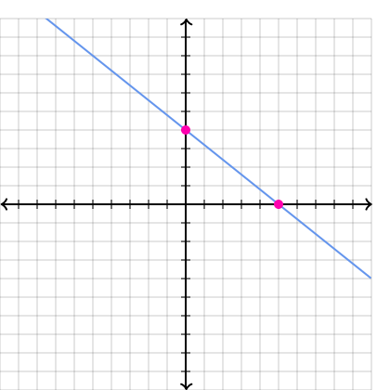
x-intercept is: __________________

y-intercept is: __________________

The slope is: ____________________
12) What is the equation of a line if the y-intercept is -8 and the slope is 5?

13) What is the equation of a line that has a slope of -3 and passes through the point (-2, 1)?

14) What is the equation of a line that passes through the two points (3, 8) and (-1, 16)?

15) Draw/Sketch a line that has a negative slope, ZERO slope and an Undefined slope.
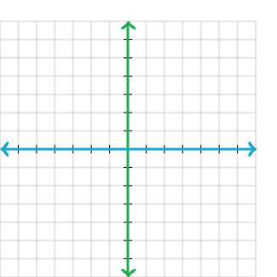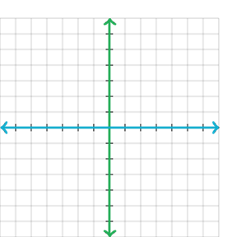
Negative Slope Zero Slope Undefined Slope
16) Plot and label each of the points on the coordinate plane shown:
A) (-1, 2)
B) (5, -3)
C) (-5, -7)
D) (0, 6)
E) (5 0)

17) Graph the lines shown on the coordinate plane and state the point where the two lines intersect.
y = $-\frac{1}{2}x+3$
3x – 4y = 8

