Name:________________________
Quadratically Inclined
Quadratic Functions can be written in Factored Form:
f (x) = a (x – r₁) (x – r₂)
Example:
f (x) = 1 (x – 5) (x + 2)
Quadratic Functions can be written in Standard Form:
$f\left(x\right)=ax^{2}+bx+c$
Example:
$f\left(x\right)=2x^{2}+4x-5$
Quadratic Functions can be written in Vertex Form:
$f\left(x\right)=a{(x-h)}^{2}+k$
Example:
$f\left(x\right)=-3{(x+6)}^{2}+7$

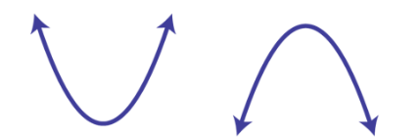
The coefficient a in the quadratic function indicates the opening of the parabola.
1.When a is positive, the parabola opens ____________________
2. When a is negative, the parabola opens ___________________
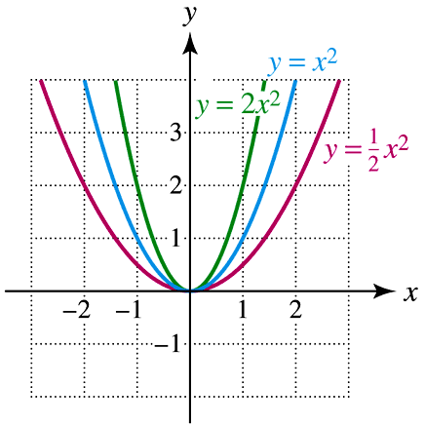
The coefficient a in the quadratic function indicates the width of the parabola
(Hint: use the graphs to the right!)
3. When a is a fraction, the parabola is ____________________
4. When a is a number greater than one,
the parabola is __________________________________

5. When the quadratic function is written in standard form, the factors will indicate the _________________ of the function.

6. When the quadratic function is written in vertex form, the factors will indicate the __________________ of the function.

7. When the quadratic function is written in factored form, the factors will indicate the __________________ of the function.

Use the equations give to find either the y-intercept, vertex, or factors of the quadratic.

8. $f\left(x\right)=-2x^{2}-8x-11$ The y-intercept of the function is _____________
9. $f\left(x\right)=-2({x+2)}^{2}-2$ The vertex of the function is _____________
10.$f\left(x\right)=5(x+12)(x-2)$ The zeros of the function are _____________ and _____________
11. $f\left(x\right)=-x^{2}+8x-18$ The y-intercept of the function is _____________
12. $f\left(x\right)=-({x-3)}^{2}-1$ The vertex of the function is _____________
13.$f\left(x\right)=-2(x+1)(x+10)$ The zeros of the function are _____________ and _____________
14. $f\left(x\right)=2x^{2}-12x+15$ The y-intercept of the function is _____________
15. $f\left(x\right)=2({x+1)}^{2}+4$ The vertex of the function is _____________
16.$f\left(x\right)=8(x-4)(x+5)$ The zeros of the function are _____________ and _____________

Use the information given to write a quadratic equation in either vertex or factored form.
17. The vertex of the function is (4, -3) and the parabola opens upward.
f (x) = _____________________
18. The zeros of the function are (-5, 0) and (4, 0) the parabola opens downward.
f (x) = _____________________
19. The zeros of the function are (-8, 0) and (3, 0) the parabola opens downward.
f (x) = _____________________
20. The vertex of the function is (3, -4) and the parabola opens upward.
f (x) = _____________________
21. The zeros of the function are (5, 0) and (2, 0), the parabola opens downward.
f (x) = _____________________
22. The vertex of the function is (-2, 0), the parabola opens upward.
f (x) = _____________________

23. Label the following key characteristics on the graph below:
- Vertex
- Zeros
- Draw the axis of symmetry and label it.
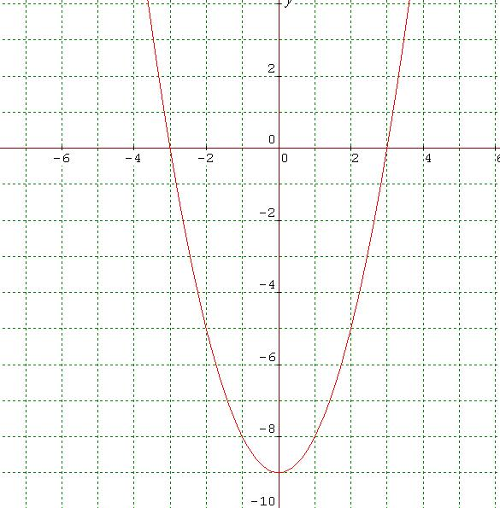
Use the graph at the right to answer the following
questions:
24) What is the vertex of the parabola?
_______________________________________________
25) What are the zeros of the function?
___________________ _________________________
26) Does the function have a maximum or a minimum?
________________________________________

